Design a Virtual LAN for LAB 1.a AND LAB 2.b

AIM :

To design and configure a Virtual Local Area Network (VLAN) for AIML and CSD departments

located in Block-A and Block-B using switches, such that faculty members of the same

department are logically grouped in the same LAN while maintaining separate broadcast

omains, and to verify connectivity using PDU packets in Cisco Packet Tracer.

PROCEDURE :

- Open Packet Tracer: Start the software and clear your workspace.
- Add Switches: Place two switches and name them Block-A and Block-B.
- Add PCs: Place two PCs at each switch for AIML and CSD faculty.
- Connect PCs: Use Straight-Through cables to connect each PC to its switch.
- Connect Switches: Link Switch-A to Switch-B using a Cross-Over cable.
- Create VLANs (Switch-A): Open the CLI and create VLAN 10 (AIML) and VLAN 20
(CSD).
- Create VLANs (Switch-B): Repeat the same VLAN creation (10 and 20) on the second switch.
- Assign Ports: Map the AIML PC ports to VLAN 10 and CSD PC ports to VLAN 20 on both switches.
- Set Trunking: Configure the link between the two switches as a Trunk port.
- Set IPs: Give each PC an IP address (PCs in the same VLAN must be in the same network).
- Test Mode: Enter Simulation Mode and use the Add Simple PDU (envelope icon) tool.
- Verify: * Success: AIML to AIML / CSD to CSD.
○ Fail: AIML to CSD.
DIAGRAM:
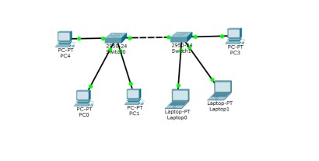

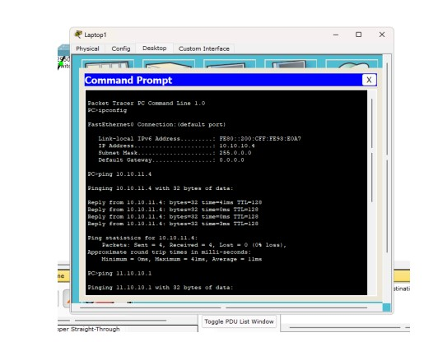

Observation

- VLAN 10 (AIML) and VLAN 20 (CSD) were created successfully on both switches.
- PCs in the same VLAN communicated successfully across Block-A and Block-B.
- The trunk link allowed VLAN traffic to pass between the two switches.

- PCs in different VLANs could not communicate with each other.
- This shows that VLANs create separate broadcast domains in the network.

RESULT:

A LAN was successfully created using a Switch-PT and five PCs. All systems were assigned
Class A IP addresses with the subnet mask 255.0.0.0, placing them in the same subnet.
Communication between all PCs was verified successfully using the ping command.

